**IMPORTANT UPDATE**

While you work on Video 2.3, you will face errors due to an SDK Version Update. Thus follow the Steps of Procedure given below to solve this.

**Microsoft Azure has updated the Python IoT SDK to Version 2.0. Version 2.0 is currently in the preview stage, and further changes might come to this SDK Version**. Thus they have moved the Version 1 client library to a deprecated GitHub Branch. The course was created and published just before the new preview update of the Version 2 SDK was released. Sadly, after the update, we can't fully clone a deprecated branch as the "recursive" cloning is not allowed in GitHub. We have manually cloned each of those recursive branches and set permissions, for your convenience.

**Steps of Procedure to complete Section 2 with old SDK version**

1. Install Raspbian Stretch (v1 SDK won’t work in Buster)

You will not be able to find the Raspbian stretch on the official downloads page as they have moved it to archives here. [Download from here.](https://downloads.raspberrypi.org/raspbian/images/raspbian-2019-04-09/)

1. Python version 3.5.3 and above. Upgrade if it is below.
2. Pip tool version should be 19.2.1 and above. Update both pip3 and pip2 tools by using the following set of commands.

i. sudo -H pip install --upgrade pip

ii. sudo -H pip3 install –upgrade pip

1. Install Adafruit’s DHT Sensor library, which will be used in the next section, and is imported in the code of this section.

i. sudo pip3 install Adafruit_DHT

1. Now download the v1 SDK that we have manually cloned from the **Resources of this Lecture**. Place it in the /home/pi directory & right click and extract it. You will get a folder like this:

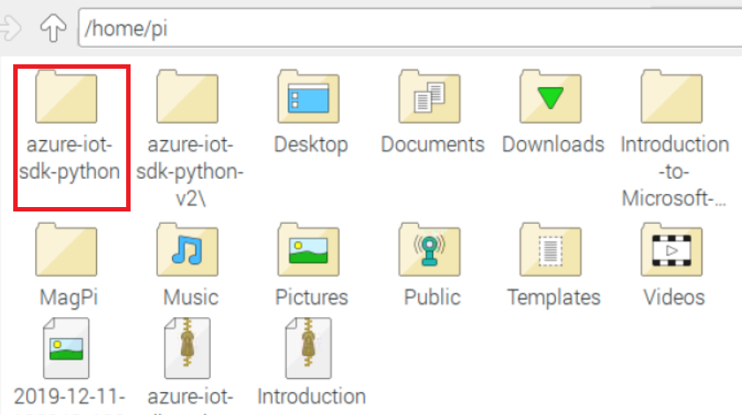

1. Now install Device client library by typing sudo pip3 install azure-iothub-device-client in the terminal
2. Now in terminal go to the following directory /home/pi/azure-iot-sdk-python/c/build_all/linux by typing cd /home/pi/azure-iot-sdk-python/c/build_all/linux . Afterward, enter the following two commands to set permissions to [build.sh](https://build.sh/) and [setup.sh](https://setup.sh/).

a. chmod +x [setup.sh](https://setup.sh/)

b. chmod +x [build.sh](https://build.sh/)

1. Next, change the directory to /home/pi/azure-iot-sdk-python/build_all/linux by using the cd command as did before. Here also you need to set permissions of [setup.sh](https://setup.sh/) and [build.sh](https://build.sh/) files by using the chmod +x command as did earlier.
2. Now you can do what is shown in the video 2.3 from 4:22 to end of the Video 2.3 (Ignore any errors)
3. For Version 1 SDK to work we need some prerequisites like libboost, libcurl and python3-dev

a. sudo apt-get install libboost-all-dev

b. sudo apt-get install libcurl4-openssl-dev

c. sudo apt-get install python3-dev

1. Now create a separate IoT Device inside the resource group we created earlier for the ESP32. In my case, I have named the new IoT Device as MyIoTDevicePi. Now copy and keep the Primary Connection String for later use.
2. Download the pi_to_azure.py code from the **Resources of this lecture**. This is based on the Ultrasonic Sensor Code shown on Video 2.4, but without compilation errors. Transfer the file to Raspberry Pi Desktop and open it with a code editor, and replace the Primary Connection String for your Azure IoT Device to line 30 of the code.
3. Go to terminal and run the code by typing sudo python3 pi_to_azure.py and on the Cloud CLI type the command as shown in 5:41 , but modified with your Hub and device name.
4. Now you can see that the connection was established and the cloud has acknowledged through a status callback.

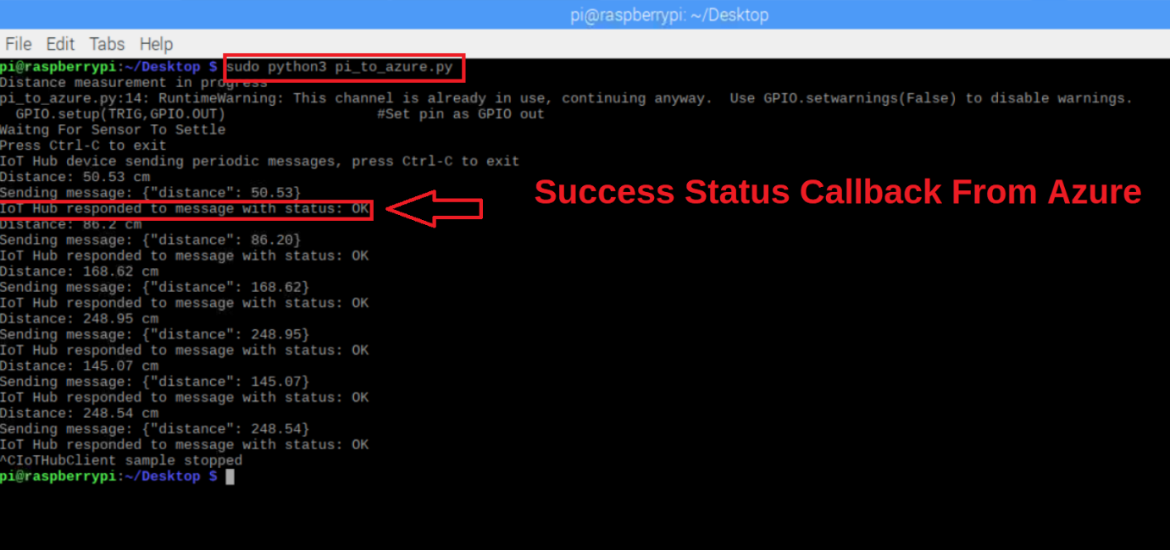

1. The output will also reflect in the Azure Cloud Shell

Please note that once the Version 2 SDK is out of preview and gets fully released, you might need to migrate the codes in the course to the new version, when the cloud services stop support for old SDK APIs. The documentation to help you out [with the migration is here.](https://github.com/Azure/azure-iot-sdk-python/blob/master/migration_guide.md)